KP06 - KP06 - Primary Cost Planning on Cost Centers

Functionality

Primary cost planning on cost centers is part of the overall business planning process.
Primary costs include expenses such as Salaries & wages, power and fuel, engineering services, traveling expenses, miscellaneous expenses.

Scenario

This transaction is used to capture planned costs to relevant cost centers.

Requirements
- Cost center group and Cost element group should be created as pre-requisite for planning.
Ensure you have the correct Plan Layout activated. Use the following menu path: Accounting → Controlling → Cost Center Accounting → Planning → Set Planner Profile (transaction KP04)

Menu Path | Accounting → Controlling → Cost Center Accounting → Planning → Cost and Activity Inputs → KP06 - Change
Transaction Code | KP06

1. Double Click on KP06 – Change

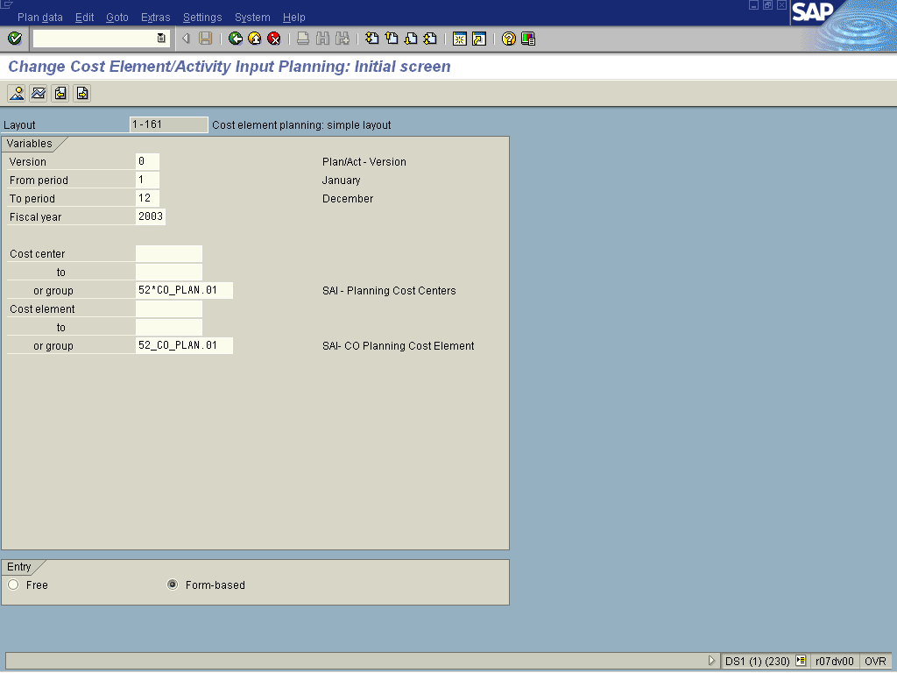
2. Update the following fields:

Field Name | Field Description | Values
Version | Three-digit number which represents the version of the forecast parameters as defined in the forecast profile | Example: 0
From Period | Number identifying a fiscal month | Example: 1
To Period | Number identifying a fiscal month | Example: 12
Fiscal Year | Period, 12 months as a rule, for which the company is to create its inventory and balance sheet. | Example: 2003
Cost center Group | Cost Center group number | Example: 52*CO_PLAN.01

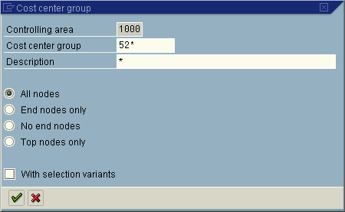

3. Update the following fields:

Field Name | Field Description | Values
Cost center group | Code identifying a grouping, for internal reporting purposes, of cost centers with similar characteristics | Example: 52*
Note: Select the With Selection Variant to select specially created cost center groups.

4. Click Enter .

Selection Cost center group (1) 11 Entries found

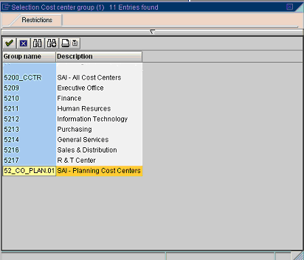

5. Select 52_CO_PLAN.01 - SAI - Planning Cost Centers in list box.

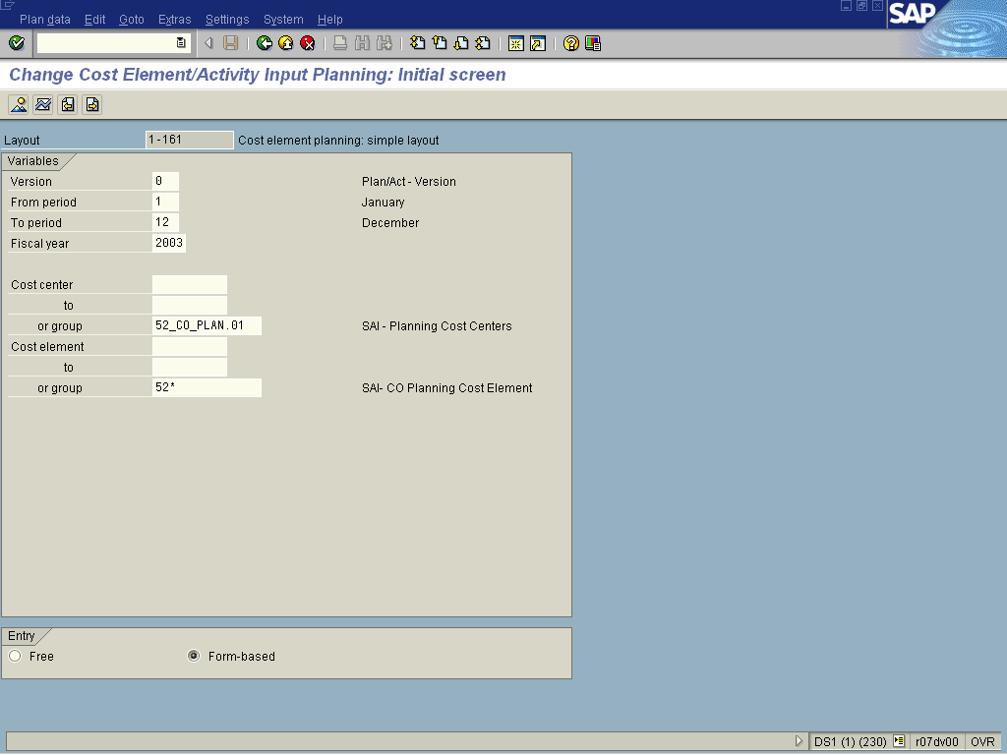

6. Update the following fields:

Field Name | Field Description | Values
or group | Cost element or group number. | Example: 52*

7. Press [F4] or Click the Search button in the or group field.

Cost element group

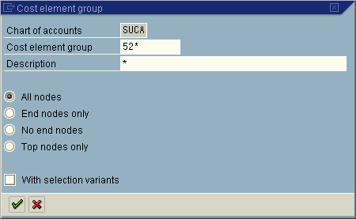

8. Update the following fields:

Field Name | Field Description | Values
Cost element group | Code identifying a grouping, for internal reporting purposes, of cost elements with similar characteristics | Example: 52*
Note: Select the With Selection Variant to select specially created cost center groups.
9. Click the Enter button.
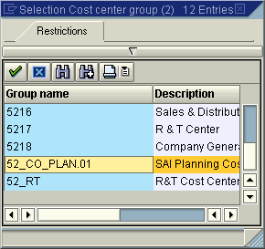
10. Select 52_CO_PLAN.01 - SAI - Planning Cost Elements in list box.
11. Click the Enter button.

Change Cost Element/Activity Input Planning: Initial screen

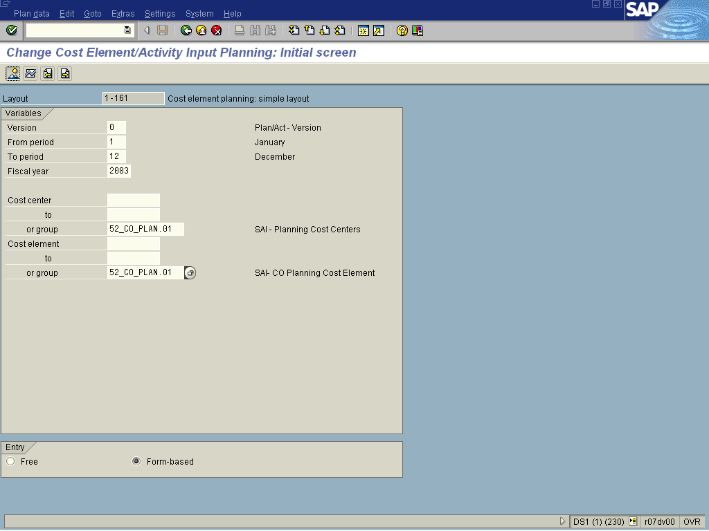

Note: The Free and Form based radio buttons at the bottom of the screen affect the layout of the screen on the next page.
Free will provide additional columns for any other cost elements that may require plan values.
Form-based will limit the selection of cost elements to the values in the group.

12. Click Overview Button .

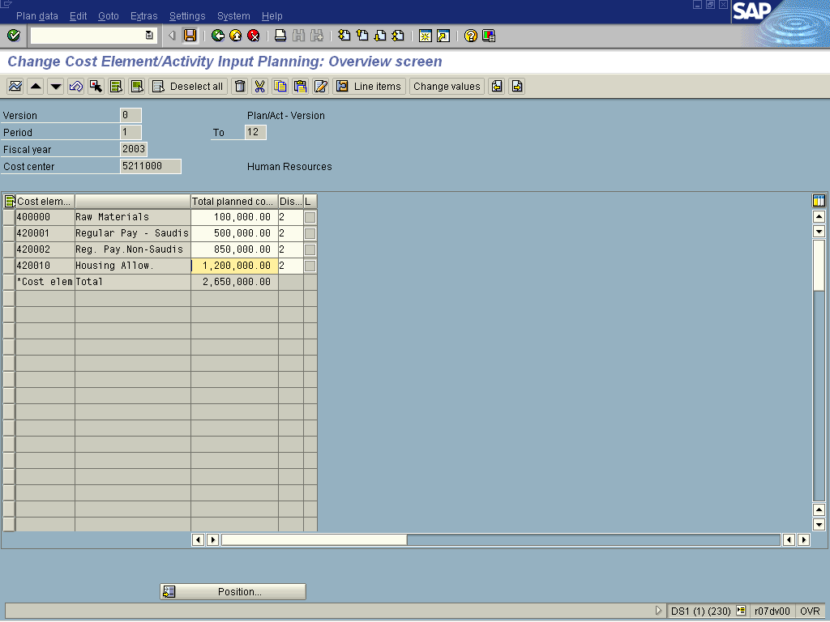

13. Update the following fields:

Field Name | Field Description | Values
Cost Element Value | Total planned values for the year. | Example: 100000
Cost Element Value | Total planned values for the year. | Example: 500000
Cost Element Value | Total planned values for the year. | Example: 850000
Cost Element Value | Total planned values for the year. | Example: 1200000
14. Click the Enter button to Validate the entries.

Note: The following buttons can be used to expedite the capture of plan values against the cost center. To update values per period, click on the Period button. Within this screen the button can be used to uplift values by percentage or amount as required. Be sure to first select the relevant periods before using this function.
15. Click Save to save your data.

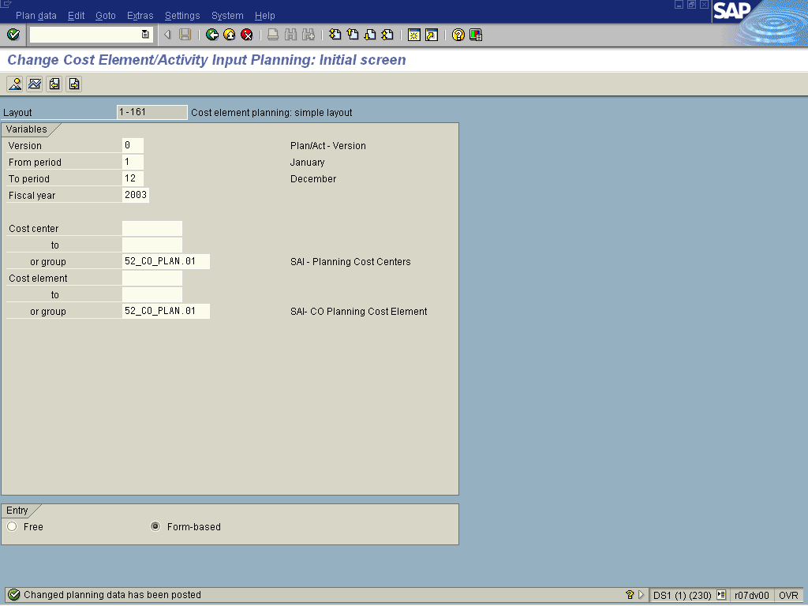
16. The message bar displays “Changed planning data has been posted”

